* Stacks of service abstraction
  + Short gets (DNS, DHCP) -> User datagrams -> Internet Datagrams
  + Byte Stream –(TCP)--> User datagrams -> Internet Datagrams
    - Web requests/responses (HTTP) -> Byte Stream
      * Youtube/Wikipedia -> Web requests/responses
    - Email sending (SMTP) -> Byte Stream
    - Email receiving (IMAP) -> Byte Stream
* Multiplexing ByteStream
  + “u8 u8” (Which byte stream; what is the byte)
    - Any reading and writing of one byte would be actually two bytes, the first byte for which byte stream and the second for the actual byte
  + “u8 u8 {u8 u8 … u8}” (which byte stream; size of payload; sequence of characters of the string chunk)
    - Any reading and writing of n bytes would be actually n + 2 bytes
    - Tagged byte stream: HTTP/2 | SPDY
* How to make ByteStream push idempotent?
  + TCP Sender Message  
     first_index  
     data   
     FIN  
    
  + This works for out-of-order or multiple deliveries. Since UDP has a checksum field, altered TCP Message would be ignored on the UDP layer.
  + What if datagrams are missing?
    - How does the sender know that a datagram needs to be sent multiple times?
    - DNS/DHCP: if we don’t receive an answer, then we retransmit. But such response/answer does not exist in `pushing` (void push())
  + Acknowledgement
    - TCP Receiver Message
      * “A B C D E F G” each byte sent as a separate TCP sender message, and “D” is not received.
      * “I got the sender message with first-index = 2, length = 1.”
        + Valid but more work. There will be one receiver message for each sender message.
      * “Got anything? Y/N. Next needed: #3.”
        + Acknowledgements are accumulative, and that make life simpler.
      * Give FIN flag a number: “A B C D E F G FIN”.  
        TCP Sender Message: {sequence number, data}  
        TCP Receiver Message: {Next needed: optional<int>}  
        and TCP Receiver Message {Next needed: optional(8)} would mean FIN is received.
      * TCP Receiver Message: {Next needed: optional<int>; available capacity:int}
        + {Next needed: optional(3); available capacity: 2} === Receiver wants to here about “DE”.
        + “DE” is the **window**. (Red area in that picture of lab 1)
    - **TCP Receiver Message: {Ack no: optional<int>; window size: int}**
  + TCP Segment  
    
  + This is the service abstraction that TCP is providing:
  + And this is what happens under the hood (and also what you will be implementing in the labs)



* + Rules of TCP
    - Reply to any nonempty TCP Server Message
* What happens when a stream ends?
  + My sender has ended its outgoing bytestream, but the incoming bytestream from the peer may not be ended.
  + When a stream ends, can the same pair of ports be used? Reusing the same pair of ports makes it not clear to tell whether a datagram belongs to the old stream or the new stream.
  + We want a new INCARNATION of the connection (new connection on the same pair of ports)
  + **Sequence number**: start from a random big number + **SYN**: this sequence number should be viewed as the beginning of a stream
    - If the sequence number doesn’t make sense on the old stream, and the SYN flag is true, the receiver knows this is a new incarnation of the connection.
    - e.g. {sequnce_no=12345, data=”abcdef”, SYN=true, FIN=true}, and {sequence_no=99999, data=”xyz”, SYN=true, FIN=true}
  + First seqno belongs to SYN flag, next seqnos belong to each byte of stream, final seqno belongs to FIN flag.
    - It is very important to have SYN flag and FIN flag delivered reliably, so therefore receiver need to acknowledge SYN seqno and FIN seqno
* What happens to TCP receiver message’s next_needed_idx field before receiving the SYN flag from the peer?
  + Without seqno:
    - I: {{first_index=0, data=”abcdef”, FIN=true}, {next_needed=0, window_size=1000}}
    - Peer: {{first_index=0, data=””, FIN=true}, {next_needed=7, window_size=1000}}
    - I: {{first_index=7, data=””, FIN=false}, {next_needed=1, window_size=1000}}
  + With seqno and SYN:
    - I: {{seqno=12340, SYN=true, data=”abcdef”, FIN=true}, {**What should this be? (before seeing 9999 from the Peer**)}}
    - Peer: {{seqno=9999, SYN=true, data=””, FIN=true}, {next_needed=12348, window_size=1000}}
    - I: {{next_needed=10001, window size =1000}}
  + ackno = optional<int> (a pair of ACK flag and ackno int)
    - I: {{seqno=12340, SYN=true, data=”abcdef”, FIN=true}, {ACK=false, ackno={missing}, window_size=1000}} (SYN)
    - Peer: {{seqno=9999, SYN=true, data=””, FIN=true}, {ACK=true, ackno=12348, window_size=1000}} (SYN+ACK)
    - I: {{ACK=true, ackno=10001, window size =1000}} (ACK)
  + (SYN) + (SYN+ACK) + (ACK) = “the three-way handshake”
  + What if the two SYN messages are sent at the same time?
    - 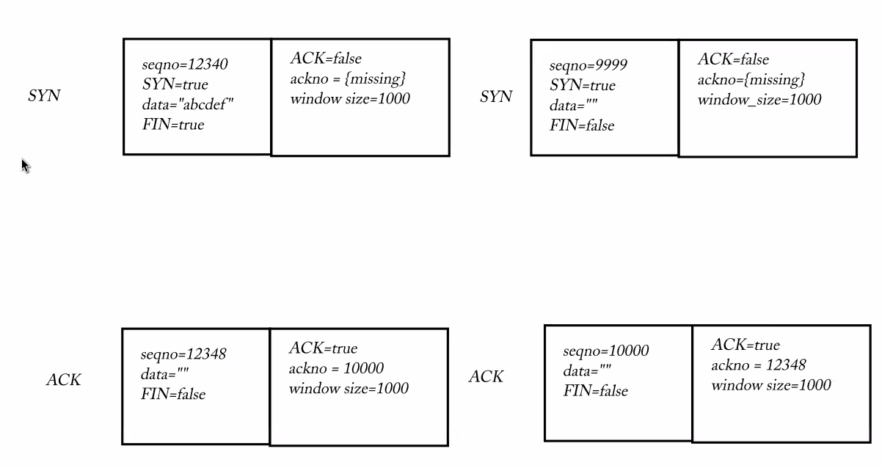
    - Not a classic “three-way handshake” but still a valid way of starting a TCP connection.
* Standardized TCP Message:
  + Sender: {sequence number, SYN, data, FIN}
  + Receiver: {ackno: optional<int>, window_size}
  + “User Datagram” info

<https://www.rfc-editor.org/rfc/rfc9293.html#name-header-format>

 0 1 2 3

0 1 2 3 4 5 6 7 8 9 0 1 2 3 4 5 6 7 8 9 0 1 2 3 4 5 6 7 8 9 0 1

+-+-+-+-+-+-+-+-+-+-+-+-+-+-+-+-+-+-+-+-+-+-+-+-+-+-+-+-+-+-+-+-+

| Source Port | Destination Port |

+-+-+-+-+-+-+-+-+-+-+-+-+-+-+-+-+-+-+-+-+-+-+-+-+-+-+-+-+-+-+-+-+

| Sequence Number |

+-+-+-+-+-+-+-+-+-+-+-+-+-+-+-+-+-+-+-+-+-+-+-+-+-+-+-+-+-+-+-+-+

| Acknowledgment Number |

+-+-+-+-+-+-+-+-+-+-+-+-+-+-+-+-+-+-+-+-+-+-+-+-+-+-+-+-+-+-+-+-+

| Data | |C|E|U|A|P|R|S|F| |

| Offset| Rsrvd |W|C|R|C|S|S|Y|I| Window |

| | |R|E|G|K|H|T|N|N| |

+-+-+-+-+-+-+-+-+-+-+-+-+-+-+-+-+-+-+-+-+-+-+-+-+-+-+-+-+-+-+-+-+

| Checksum | Urgent Pointer |

+-+-+-+-+-+-+-+-+-+-+-+-+-+-+-+-+-+-+-+-+-+-+-+-+-+-+-+-+-+-+-+-+

| [Options] |

+-+-+-+-+-+-+-+-+-+-+-+-+-+-+-+-+-+-+-+-+-+-+-+-+-+-+-+-+-+-+-+-+

| :

: Data :

: |

+-+-+-+-+-+-+-+-+-+-+-+-+-+-+-+-+-+-+-+-+-+-+-+-+-+-+-+-+-+-+-+-+

Note that one tick mark represents one bit position.



* Wireshark tool